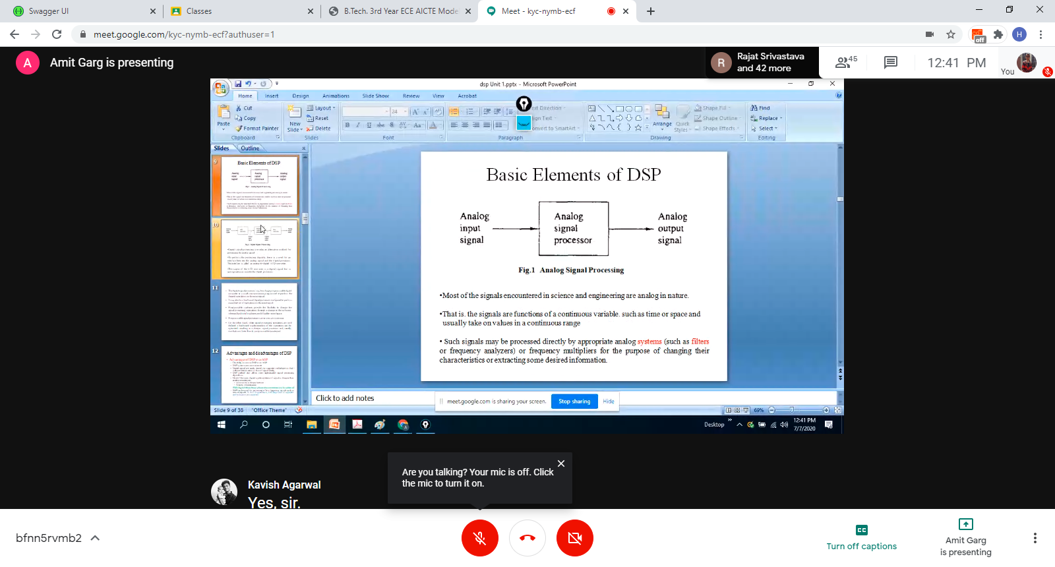DIGITAL SIGNAL PROCESSING

* **Processing signal in digital domain.**
* Signal may be digital or analog.
* System == filter
* Changing characteristic of signal

BLOCK DIAGRAM:

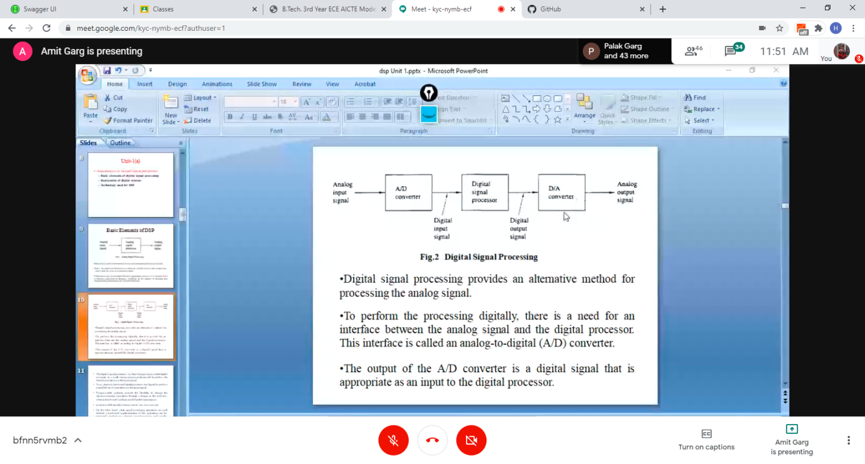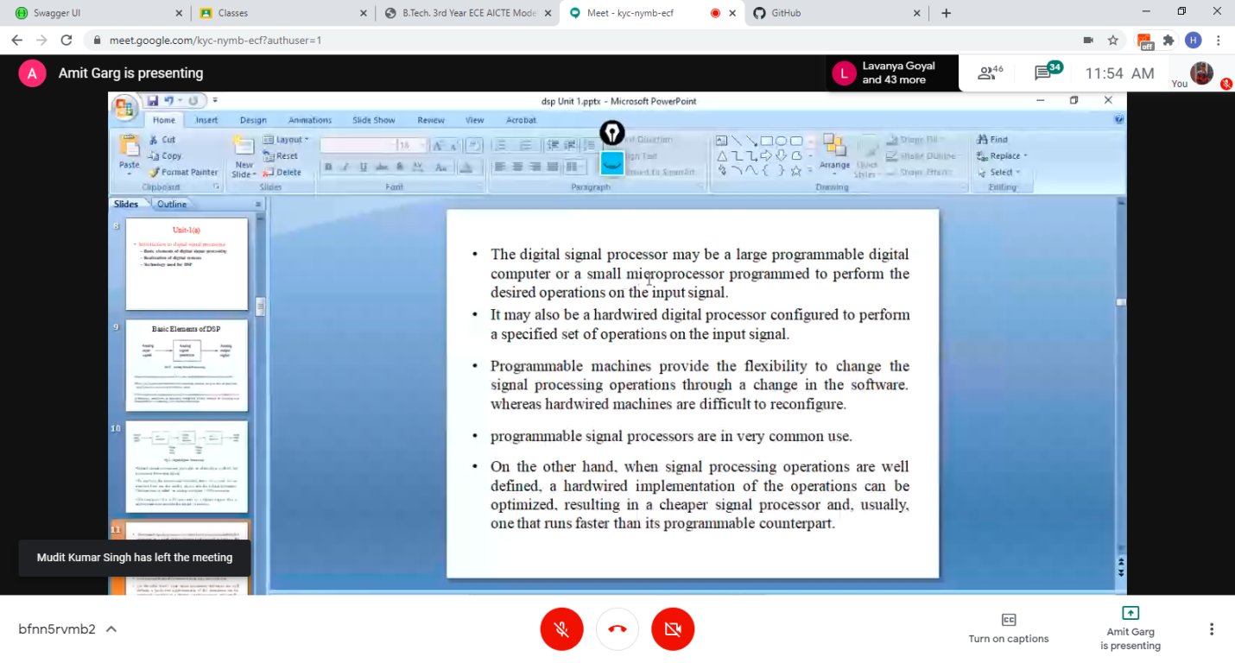

Advantages of DSP over ASP:

l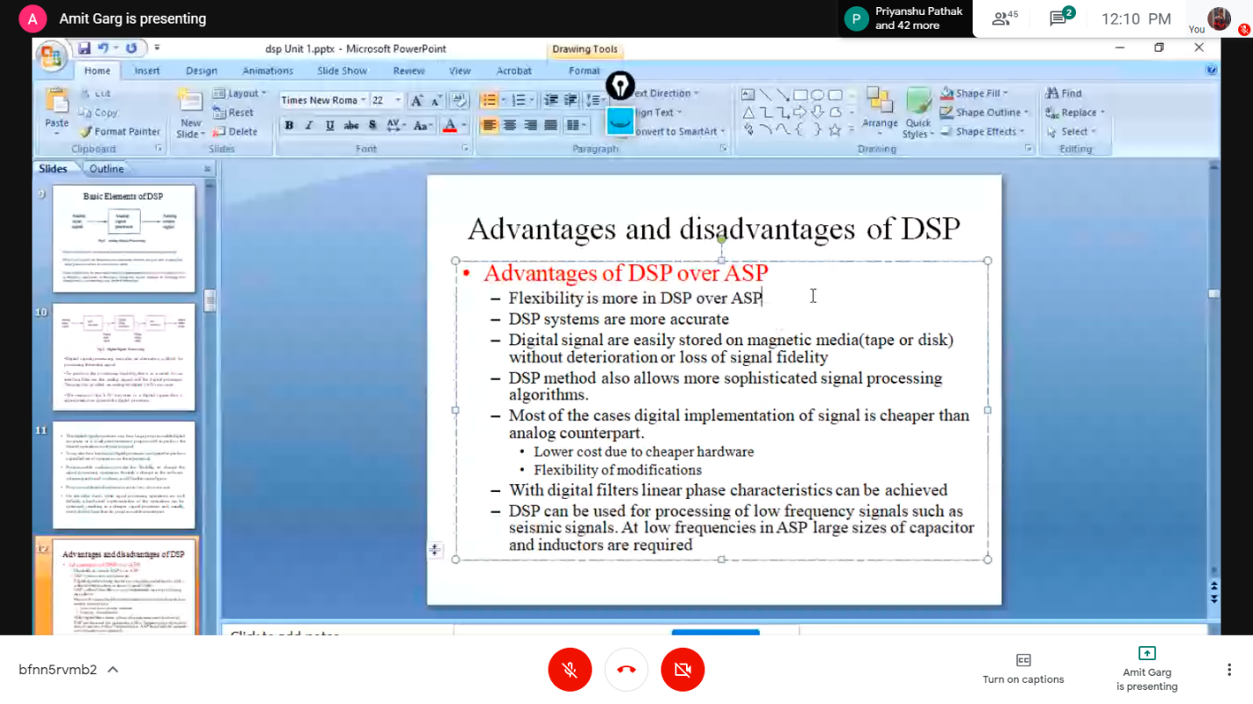

Applications in DSP :

* Telecommunications
* Military : lock target position
* Consumer electronics
* Instrumentation and control
* Digital image processing
* Speech processing
* Medicine : ct scan, x-rays, etc
* Seismology : low frequency signal transmission and processing
* Signal filtering : for example - in Google meet the voice is transmitted after filtering noise.

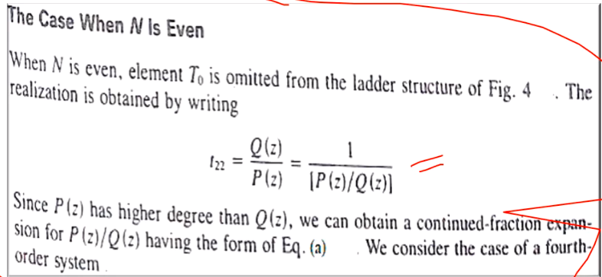

Imp question